Jiajun Yu

Aug 15, 2021

Foundations of Programming, SQL

Assignment 06

**SQL View, Function and Stored Procedure**

**Introduction**

In this paper, I will go over the questions about SQL view, function and stored procedure and will explain when we shall use those statements.

**1. Explain when you would use a SQL View.**

Definition

We can create a view by selecting fields from one or more tables from the database.In order to create View, we can use CREATE VIEW statement. View can be created from a single table or multiple tables.

Syntax of SQL view:

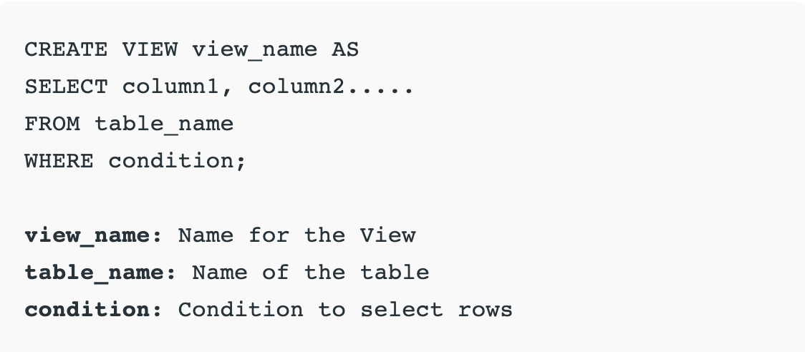

*Figure 1: screenshot from* [*https://www.geeksforgeeks.org/sql-views/*](https://www.geeksforgeeks.org/sql-views/)

Purpose

There are a couple of reasons that we shall choose to use SQL view.

* Need to represent a subset of data in one table
* Combine more than one table to a single virtual table
* Decrease the complexity of data
* Need to simplify the complex queries
* Change the structure of table
* Remove the redundancy of data
* Do calculation in a View query
* Format the table to be easier for end users
* Denormalize data

**2. Explain the differences and similarities between a View, Function, and Stored Procedure.**

Similarities

View, Function, and Stored Procedure provide the possibilities to store queries for later executions and reduce the redundancy so there are less repeated procedures needed. Less code means less difficulty of data maintenance.

Difference

View, Function, and Stored Procedure have different purposes when storing queries and each statement has their own benefits and constraints.

* The main purpose of using View is to centralize a query in an object which is called from other queries. But View doesn’t provide the possibility to parameterize the input. And No Insert/Update/Delete (DML) operations can be used with View.
* Regarding Function, its CREATE FUNCTION statement can perform the defined task, we can simply pass the parameter with the function name, once the function returns back values, we can store the value for later usage.
* Stored Procedure can store SQL query statements for easy execution. It will work when we need to store a single or multi-step process in one object for using later. It accepts parameters but could not be used for building blocks in a large query

**Summary**

Overall, View, Function, and Stored Procedure are able to store queries for later executions.

View is a “Virtual” table while no physical data has been stored by the view and no parameters can be passed, no DML operations can be applied under View.

Functions are made up with one more multiple transact statements to encapsulate code for reuse.

Stored procedure is a group of transact statements compiled into one execution plan and is able to modify one or several tables.